13.2 Getting your bearings

Sprint 13 Incident Investigation

← Use the Document tabs to locate the notes for each task in this investigation.

13.2.1 Device

13.2.1 Finding the attacking device
Instructions for completing this task are located here. Use this worksheet to keep notes as you complete it.

40.80.148.42

index=client1 sourcetype=stream:dns "solidaritedeproximite.org"
| table _time src_ip query answer

13.2.2 Tool

13.2.2 Determining the tool
Instructions for completing this task are located here. Use this worksheet to keep notes as you complete it.

Acunetix

index=client1 sourcetype=stream:http
| table _time src_ip dest_ip uri http_method http_user_agent

13.2.3 Exploited CMS

13.2.3 Identifying the exploited CMS
Instructions for completing this task are located here. Use this worksheet to keep notes as you complete it.

Joomla
index=client1 sourcetype=stream:http "imreallynotbatman.com"
| table _time uri http_method src_ip

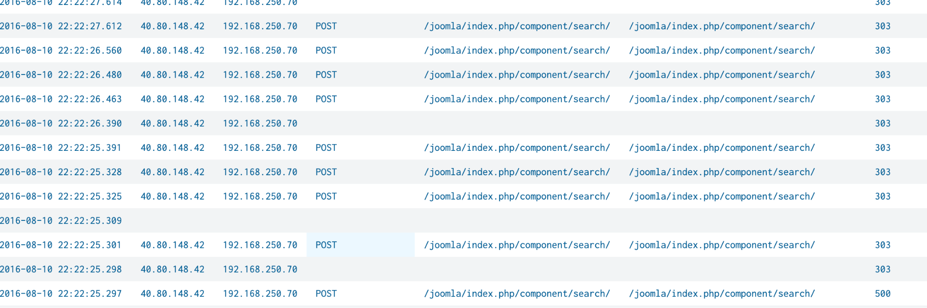
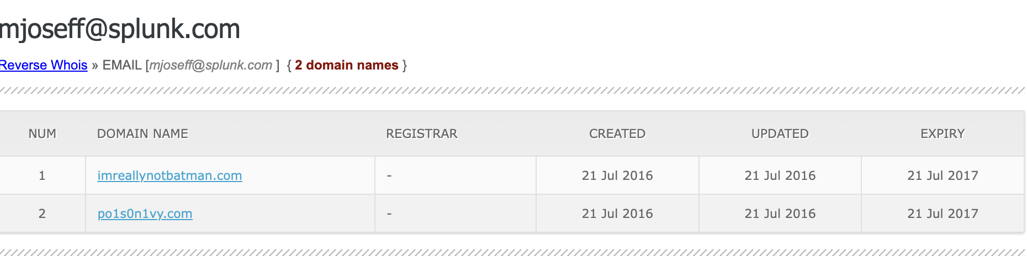

13.2.4 Defacement image’s filename

13.2.4 Establishing the defacement image’s filename
Instructions for completing this task are located here. Use this worksheet to keep notes as you complete it.

/poisonivy-is-coming-for-you-batman.jpeg

index=client1 sourcetype=stream:http "imreallynotbatman.com"
| table _time src_ip dest_ip uri http_method

13.2.5 FQDN

13.2.5 Associating the malicious FQDN
Instructions for completing this task are located here. Use this worksheet to keep notes as you complete it.

prankglassinebracket.jumpingcrab.com

index=client1 sourcetype=stream:dns answer="*<malicious_IP>*"
| table query answer

13.2.6 Pre-staging IP

13.2.6 Discovering the pre-staging IP address
Instructions for completing this task are located here. Use this worksheet to keep notes as you complete it.

23.22.63.114

index=client1 sourcetype=stream:dns
| stats count by dest_ip

13.2.7 APT email

13.2.7 Using OSINT to confirm the APT group’s email address
Instructions for completing this task are located here. Use this worksheet to keep notes as you complete it.

lillian@po1s0n1vy.com
Dynamic DNS domain: prankglassinebracket.jumpingcrab.com
Malicious IP: 23.22.63.114
Using Whoxy

13.2.8 Brute-force IP

13.2.8 Assessing the brute-forcing IP address
Instructions for completing this task are located here. Use this worksheet to keep notes as you complete it.

23.22.63.114

13.2.9 Malware filename

13.2.9 Figuring out the malicious executable’s filename
Instructions for completing this task are located here. Use this worksheet to keep notes as you complete it.

3791.exe

13.2.10 MD5 hash

13.2.10 Locating the MD5 hash of that executable
Instructions for completing this task are located here. Use this worksheet to keep notes as you complete it.

AAE3F5A29935E6ABCC2C2754D12A9AF0

index=client1 "3791.exe" CommandLine="3791.exe"
| rex field=_raw "MD5=(?<hash>[A-Fa-f0-9]{32})"
| table hash

13.2.11 SHA256 hash

13.2.11 Using OSINT to find the SHA256 of an APT group’s custom malware
Instructions for completing this task are located here. Use this worksheet to keep notes as you complete it.

MD5
aae3f5a29935e6abcc2c2754d12a9af0

SHA-1
65df73d77324d008c83c3e57b445df0fd43a3a51

SHA-256
ec78c938d8453739ca2a370b9c275971ec46caf6e479de2b2d04e97cc47fa45d

13.2.12 Custom hex

13.2.12 Figuring out the malware’s custom hex
Instructions for completing this task are located here. Use this worksheet to keep notes as you complete it.

4e 65 6c 20 6d 65 7a 7a 6f 20 64 65 6c 20 63 61 6d 6d 69 6e 6f 20 64 69 20 6e 6f 73 74 72 61 20 76 69 74 61 20 6d 69 20 72 69 74 72 6f 76 61 69 20 70 65 72 20 75 6e 61 20 73 65 6c 76 61 20 6f 73 63 75 72 61

I open VIRUSTOTAL and enter

( SHA 256) ec78c938d8453739ca2a370b9c275971ec46caf6e479de2b2d04e97cc47fa45d into the search and then click community tab and there it was posted by user TRBOTS 7 years ago.

13.2.13 WHOIS info

13.2.13 Using OSINT to discover interesting WHOIS information
Instructions for completing this task are located here. Use this worksheet to keep notes as you complete it.

lasciate ogni speranza, voi ch'intrate

Using the malicious IP= 23.22.63.114
I Open virustotal go to community tab copy
6c 61 73 63 69 61 74 65 20 6f 67 6e 69 20 73 70 65 72 61 6e 7a 61 2c 20 76 6f 69 20 63 68 27 69 6e 74 72 61 74 65 hex code and decode it in cyberchef

13.3 Analyzing the brute force attack

13.3.1 Passwords used

13.3.1 Identifying passwords used
Instructions for completing this task are located here. Use this worksheet to keep notes as you complete it.

12345678

index=client1 imreallynotbatman.com sourcetype="stream:http" http_method=POST dest_ip="192.168.250.70" src_ip="23.22.63.114" form_data="*passwd=*" | rex field=form_data "passwd=(?<extracted_password>\\w+)"

13.3.2 6-char passwords

13.3.2 Figuring out 6-character passwords
Instructions for completing this task are located here. Use this worksheet to keep notes as you complete it.

Yellow

coldplay.csv

index=client1 sourcetype=stream:http "/joomla/administrator/index.php" "passwd="
| rex field=form_data "passwd=(?<password>[^&]+)"
| eval password=lower(password)
| lookup coldplay.csv song as password OUTPUT song
| where isnotnull(song) AND len(password)=6
| table password

13.3.3 Admin password

13.3.3 Establishing the correct admin password
Instructions for completing this task are located here. Use this worksheet to keep notes as you complete it.

Batman

index=client1 imreallynotbatman.com sourcetype="stream:http" dest_ip="192.168.250.70" http_method="POST" form_data="*passwd=*" | rex field=form_data "passwd=(?<passwd>\w+)"
| stats count by passwd | where count > 1 | stats count by http_user_agent, userpassword

src_content: username=admin&passwd=batman&option=com_login&task=login&return=aW5kZXgucGhw&e5ec827a3f67ce0efc546d81f7356acc=1

13.3.4 Average password length

13.3.4 Determining the average password length
Instructions for completing this task are located here. Use this worksheet to keep notes as you complete it.

6

index=client1 sourcetype=stream:http "/joomla/administrator/index.php"
| rex field=form_data "passwd=(?<password>[^&]+)"
| eval length=len(password)
| stats avg(length) as avg_length
| eval rounded_up=ceil(avg_length)

6.174334140435835

13.3.5 Seconds between events

13.3.5 Calculating seconds elapsed between two events
Instructions for completing this task are located here. Use this worksheet to keep notes as you complete it.

92.17

index=client1 sourcetype=stream:http form_data="*username*passwd*"
| rex field=form_data "passwd=(?<passwd>\w+)"
| search passwd="batman"
| sort 0 _time
| delta _time as seconds
| table _time passwd seconds

13.3.6 Unique password count

13.3.6 Reckoning the unique password count
Instructions for completing this task are located here. Use this worksheet to keep notes as you complete it.

412

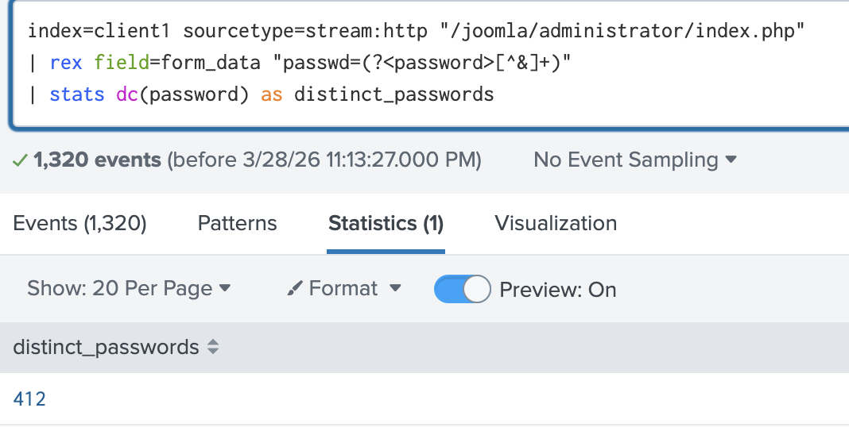

13.4 Digging in deeper

13.4.1 Host IP

13.4.1 Determining a host’s IP address
Instructions for completing this task are located here. Use this worksheet to keep notes as you complete it.

192.168.250.100

index=client1 host=we8105desk earliest=08/24/2016:00:00:00 latest=08/24/2016:23:59:59
| stats values(src_ip) as ip_addresses

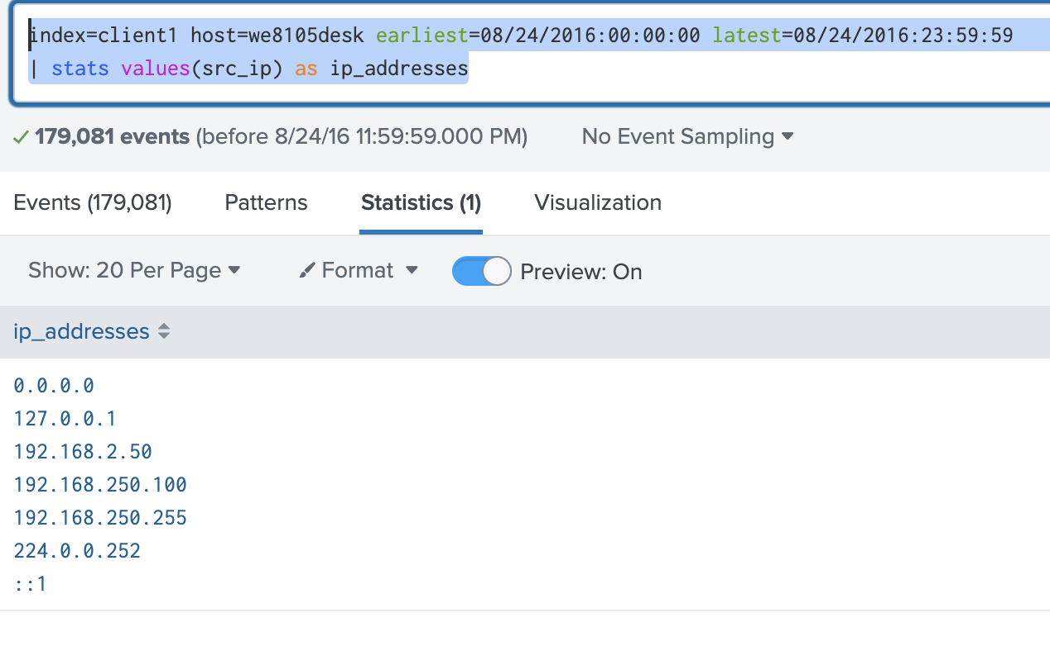

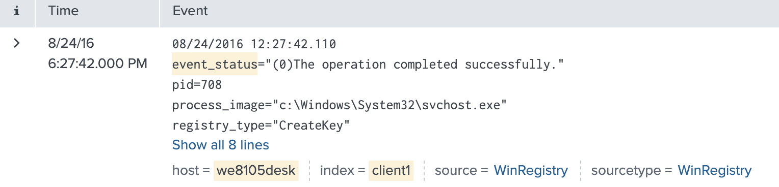

13.4.2 Least frequent alert

13.4.2 Calculating the least frequent alert
Instructions for completing this task are located here. Use this worksheet to keep notes as you complete it.

2816763

index=client1 sourcetype=suricata "Cerber"
| stats count by alert.signature alert.signature_id
| sort 0 + count

LEAST

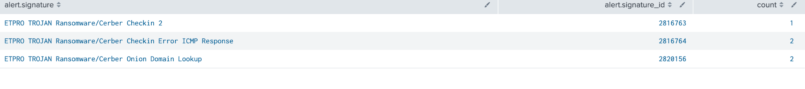

13.4.3 Ransomware FQDN

13.4.3 Working out which FQDN the ransomware redirects to
Instructions for completing this task are located here. Use this worksheet to keep notes as you complete it.

Cerberhhyed5frqa.xmfir0.win

index=client1 sourcetype=suricata "Cerber"
| table _time src_ip dest_ip http.hostname alert.signature

13.4.4 Malicious URL by host

13.4.4 Discovering the first malicious URL visited by a host
Instructions for completing this task are located here. Use this worksheet to keep notes as you complete it.

solidaritedeproximite.org

index=client1 host=we8105desk sourcetype=stream:http earliest=08/24/2016:00:00:00 latest=08/24/2016:23:59:59
| table _time http_host uri src_ip dest_ip
| sort _time

13.4.5 VB script run during infection

13.4.5 Locating the VB script run during infection
Instructions for completing this task are located here. Use this worksheet to keep notes as you complete it.

4490

index=client1 earliest=0 source="WinEventLog:Microsoft-Windows-Sysmon/Operational" | rex max_match=1 "<EventID>(?<EventID>\d+)</EventID>"
| search EventID=1
| rex max_match=1 "<Data Name='CommandLine'>(?<CommandLine>[^<]+)" | eval script_field_length = len(CommandLine)
| table _time, host, CommandLine, script_field_length

13.4.6 USBs

13.4.6 Digging up evidence of USBs connected to a device
Instructions for completing this task are located here. Use this worksheet to keep notes as you complete it.

MIRANDA_PRI

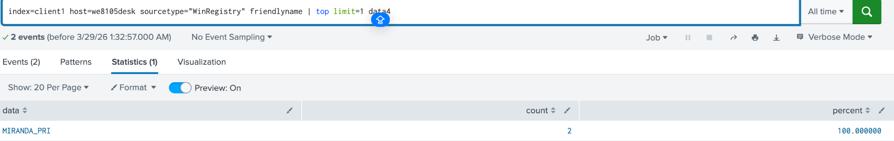

13.4.7 File server

13.4.7 Identifying the file server
Instructions for completing this task are located here. Use this worksheet to keep notes as you complete it.

192.168.250.20

index=client1 host="we8105desk" sourcetype=WinRegistry fileshare
| head 1

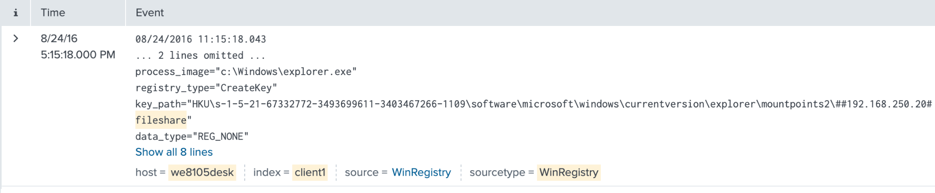

13.4.8 Unique files

13.4.8 Computing unique files encrypted by the ransomware
Instructions for completing this task are located here. Use this worksheet to keep notes as you complete it.

257

index=client1 host=we9041srv app="win:unknown"
| where like(lower(Relative_Target_Name), "%.pdf")
| stats dc(Relative_Target_Name)

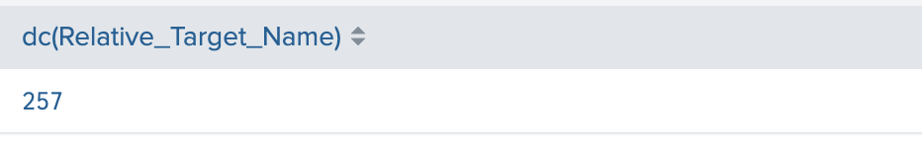

13.4.9 Process

13.4.9 Tracking down the responsible process
Instructions for completing this task are located here. Use this worksheet to keep notes as you complete it.

3968

index=client1 sourcetype="xmlwineventlog" "121214.tmp" | rex max_match=1 "<Data Name='ProcessId'>(?<ProcessId>[^<]+)"
| rex max_match=1 "<Data Name='ParentProcessId'>(?<ParentProcessId>[^<]+)"
| rex max_match=1 "<Data Name='Image'>(?<Image>[^<]+)"
| rex max_match=1 "<Data Name='CommandLine'>(?<CommandLine>[^<]+)"
| rex max_match=1 "<Data Name='ParentImage'>(?<ParentImage>[^<]+)"
| rex max_match=1 "<Data Name='ParentCommandLine'>(?<ParentCommandLine>[^<]+)"
| table _time, ProcessId, ParentProcessId, Image, CommandLine, ParentImage, ParentCommandLine
| sort _time asc

13.4.10 Counting files

13.4.10 Calculating the number of encrypted files of a specific format
Instructions for completing this task are located here. Use this worksheet to keep notes as you complete it.

401

index=client1 source="WinEventLog:Microsoft-Windows-Sysmon/Operational"
| rex max_match=1 "<EventID>(?<EventID>\d+)</EventID>"
| rex field=_raw "<Data Name='TargetFilename'>(?<TargetFilename>[^<]+)</Data>"
| search host="we8105desk"
| where EventID=2
| where like(TargetFilename, "C:\\Users\\bob.smith.WAYNECORPINC\\%.txt")
| stats dc(TargetFilename) as unique_txt_files_encrypted

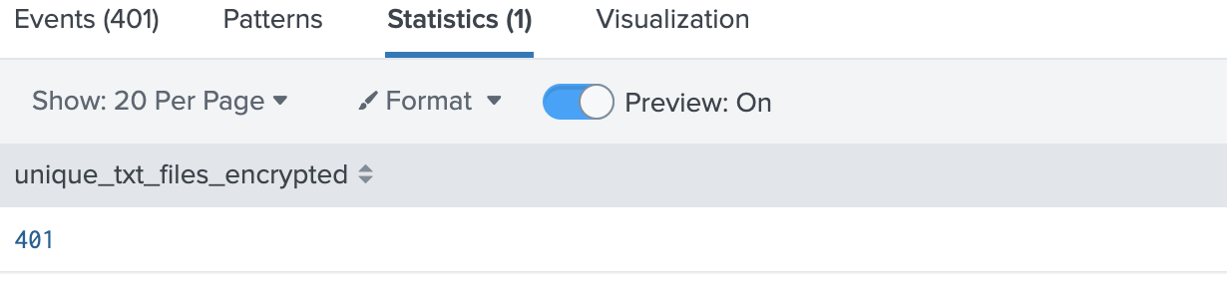

13.4.11 Cryptor's filename

13.4.11 Locating the cryptor’s filename
Instructions for completing this task are located here. Use this worksheet to keep notes as you complete it.

Mhtr.jpg

index=client1 sourcetype="stream:http" src_ip="192.168.250.100" uri!="*/*.crl" uri!="/favicon.ico"
| table _time, src_ip, dest_ip, uri, http_user_agent, http_method, bytes_in, bytes_out

Odd one

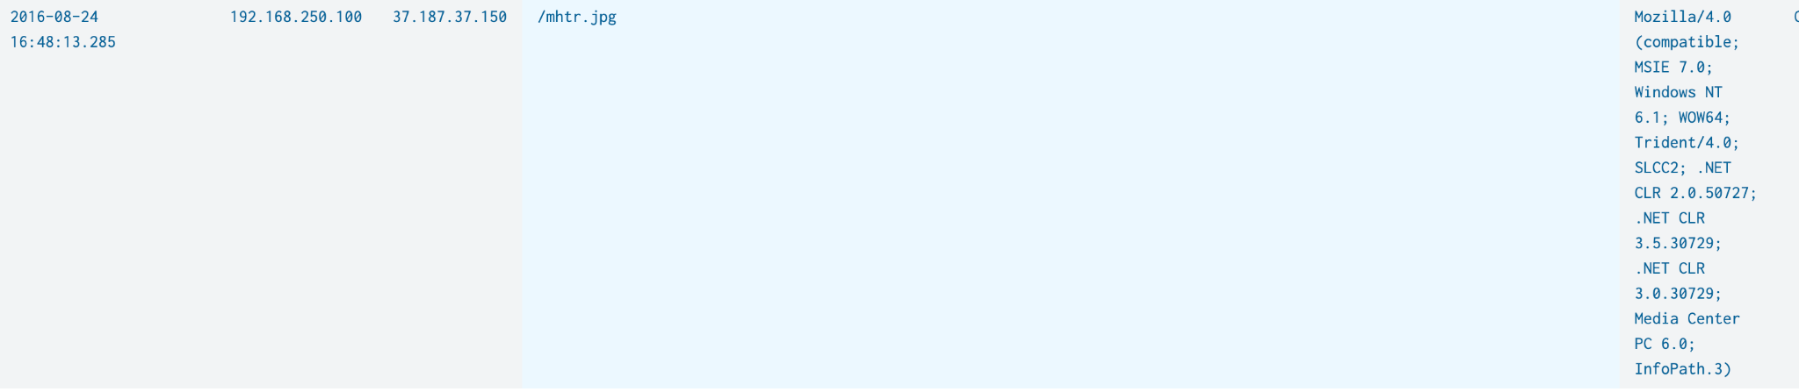

13.4.12 Obfuscation

13.4.12 Using OSINT to determine the ransomware’s obfuscation technique
Instructions for completing this task are located here. Use this worksheet to keep notes as you complete it.

Steganography

Steganography is the art of hiding information inside other seemingly innocuous files. Unlike encryption, which scrambles data, steganography conceals its very existence. A payload can be embedded in a file with an extension that appears to be a normal image. Traditional security tools might overlook it because it doesn’t behave like a known threat…on the surface.
- A good way to think about steganography is like writing a secret message using invisible ink on a postcard. If someone scans for threatening letters, they’ll see nothing alarming. But if they know to shine a UV light, a hidden message appears.
- Security analysts need to be aware of steganography because it’s an advanced evasion tactic. It’s not enough to rely on file extensions or antivirus tools alone.

In the infection chain i investigated:
- VBScript executed via wscript.exe
- The script downloaded mhtr.jpg
- The .jpg file looked harmless but actually contained hidden executable code
- The hidden payload was then extracted and used in the Cerber ransomware attack

